File permissions in Linux

Project description
Me and my research team are tasked to ensure users on this team are authorized with the appropriate permissions. We use this to ensure the principle of least privilege. This keeps data safe and ensures that those who need it have access to it.

Check file and directory details
I used the command ls -la, displayed on the first line. This command shows all the permissions that the user, group and other have over the files in the /home/researcher2/projects,
including also the hidden files.
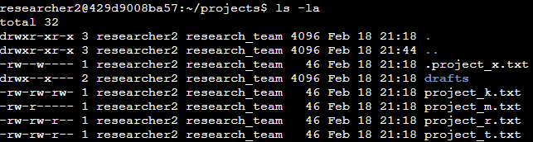

Describe the permissions string
For an example, we would use the file project_k.txt. The first 10 characters in the output show the permissions and type of the object. The first character “–“ is used to represent the type of object, in this instance is a file. If it was a folder, it would have been a “d” character. The second, third and fourth characters “rw-“ for the permission for the user, “r” stands for read, “w” stands for write and “–“ means that he does not have permission to perform that task, which is execute. If he had the permission to execute, it would have been a “x” instead of the “-“. The fifth, sixth and seventh characters are the permission for the group, that are the same as the user. The eight, ninth and tenth are permissions for the other, also same as the user.

Change file permissions
I used the ls -la command to see all the write permissions that others have over the folder projects. We see that others have write permission on the project_k.txt. I used chmod o-w *, to remove all the write permission of others in all the files in the projects. After that, I checked with the ls -la command to see that the others write access has been removed.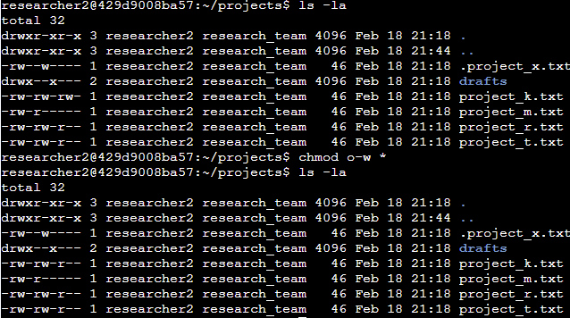

Change file permissions on a hidden file
I used the chmod u-w,g-w,o-w .project_x.txt . This command eliminates all write permission for all individuals in the system for the hidden file .project_x.txt.
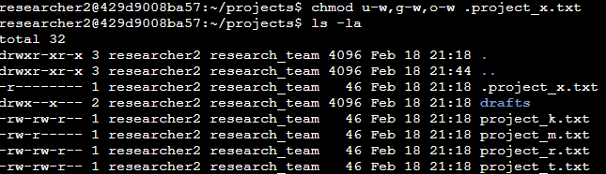

Change directory permissions
To make only so that the user researcher2 can have access to the folder drafts, we used the command chmod g-rwx,o-rwx drafts.
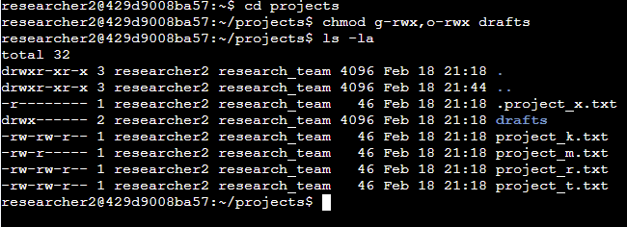

Summary
In this scenario, i was tasked with making sure that others do not have access to any of the files, .project_x.txt file should not have write permissions for anyone, but the user and group should be able to read the file, and user researcher2 should be allowed to access the drafts directory and its contents.

